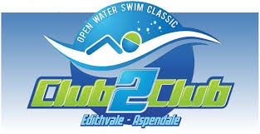

Saturday February 23rd 2019
Register now at www.club2clubswim.com.au
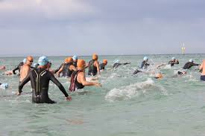
1.8Km Open Water Swim Classic

Entry fee is $38 (pre register) or $45 on the day.
Pre registration is preferred as all competitors will receive a T-shirt on the day.
All proceeds support both Life Saving Clubs in purchasing critical lifesaving equipment and resources to help patrol our local beaches.
Prizes will be awarded to winners from each division.

